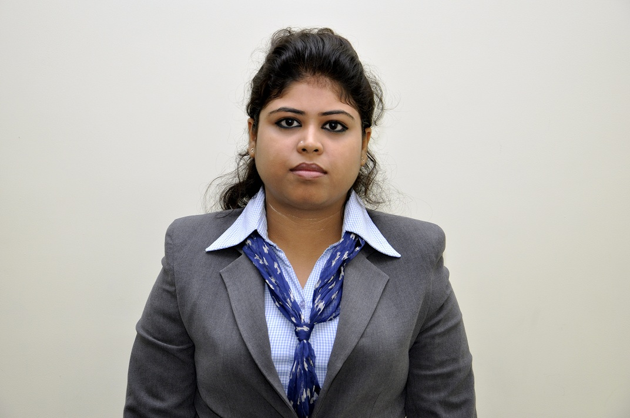

ARPITA SARKAR

Mob: 09836071251

**Email:** arpi15sarkar@gmail.com

**JOB VISION:** To be engaged in productive work for betterment of self and organization.

SNAPSHOT

Career Snapshot: Executive Trainee at Karvy with 1 year 3 months and 5 days work experience.

KEY RESPONSIBILTIES:

* Lead generation.
* Responsibility for clients’ acquisition and client servicing.
* Handling customer's queries.
* Ensure customer profiling and categorization of customers.
* Handling corporate events and tie ups.
* Generating revenue for the organization.

Master of Business Administration (Marketing major & Finance minor) from Future

Business School (W.B.U.T.)

A Graduate with B.COM(H) (MARKETING) from College (C.U.)

Projects handled for METRIC CONSULTANCY Limited at Kolkata.

Projects handled for IMRB during summer internship project.

Projects done on HOME SHOP 18,ITOPS, MOPE PROJECT&DEPARTMENT OF POST from IMRB.

Possess good communication skills that help to organize events and group activities .

A patient learner and sensitive to the need of regular business environment.

**ACADEMIC QUALIFICATIONS:**

**MBA (Marketing / Finance)** Future Business School W.B.U.T ( 2011-2013) 6.82%

**B.COM (H) (Marketing)** Heramba ChandraCollege (C.U.) (2007- 2010) 50.5%

**12th** **Standard**  Ballygunge Shiksha Sadan School(W.B.B.H.S.E.)2007 63.5%

**10th** **Standard**  St. Johns’ Diocesan Girls’ H.S. School (W.B BOARD)2005 62.5%

**PROJECTS HANDLED in MBA**

**Project :**  Summer Internship Project at  **INDIAN MARKETING RESEARCH BUREAU (IMRB) INTERNATIONAL**

**Title MEASUREMENT OF CUSTOMER SATISFACTION AVAILING THE INDIAN POSTAL SERVICE**

**Duration : Two Months** , Location – **Kolkata**

**Description :**

* To determine customers expectation and perception.
* To measure the gap between expectation and perception.
* To understand the Customer satisfaction and ratings of different service attributes in postal service.
* To measure the association between customer satisfaction and loyalty of the service.
* To find out the association between customer satisfaction and customer referral
* To understand the association between customer satisfaction and reuse pattern to avail the same service.

**PROFESSIONAL EXPERTISE**

IT Skill

Operating System: Windows 2000, Windows 7,Windows 8

Multimedia Packages:PAGEMAKER,CORELDRAW, PHOTOSHOP CS4,INDESIGN CS4,ILLUSTRATOR CS4, INDESIGN CS4,FLASH CS4, SOUNFORGE.

Other Application Software: Ms. Word, Ms. Excel, Ms. PowerPoint

Well familiar with the Internet: Browsing, E-Mailing.

**ACHIEVEMENTS:**

Attended management development programme.

Attended ERP ( MICROSOFT DYNAMICS) session.

**HOBBIES**

Painting, Sketching, Art & Craft, Graphic Designing, listening music.

**PERSONAL VITAE**

**Date of Birth :** 15/04/1989

**Languages :** English, Hindi, Bengali

**Address : :** 5/6, Shivmandir Road, KOLKATA - 700096.

**Date:**

**SIGNATURE**